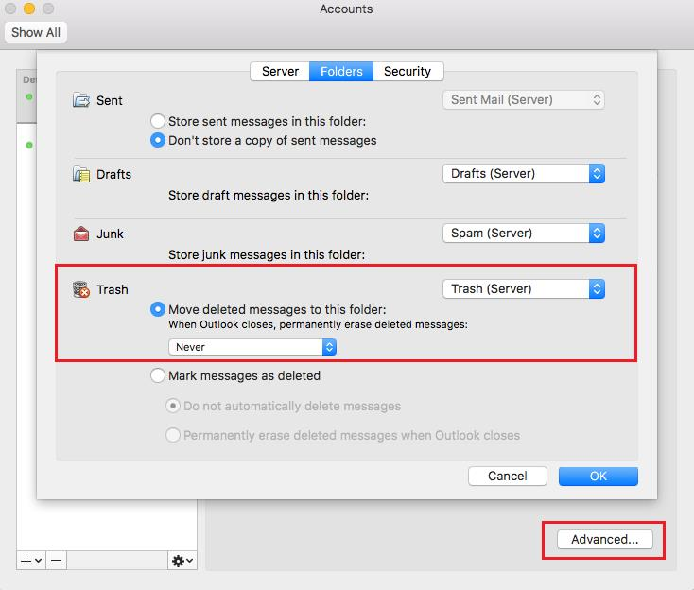  
  
<https://support.apple.com/de-de/guide/iphone/iph65f82af3e/ios>  
  
<https://support.apple.com/de-de/HT206986>

<https://support.apple.com/de-de/HT203483>  
  
<https://support.apple.com/de-de/HT203413>  
  
<https://apple.stackexchange.com/questions/29891/icloud-and-iphone-calendar-have-different-timezones>

<https://www.igeeksblog.com/how-to-change-time-zone-in-iphone-calendar-app/>

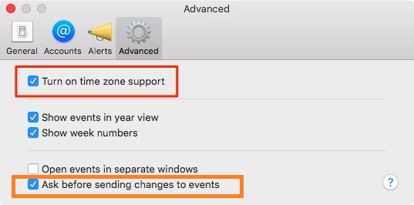  
  
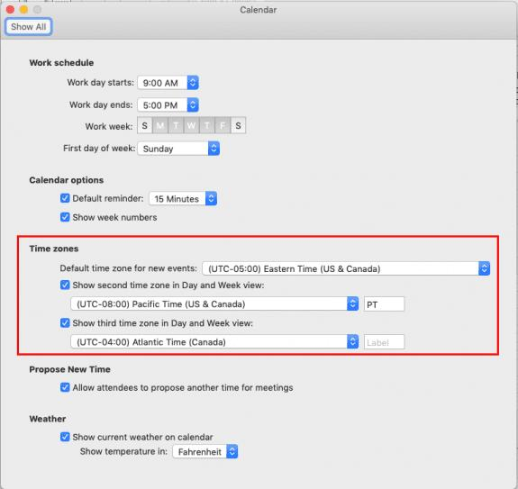  
  
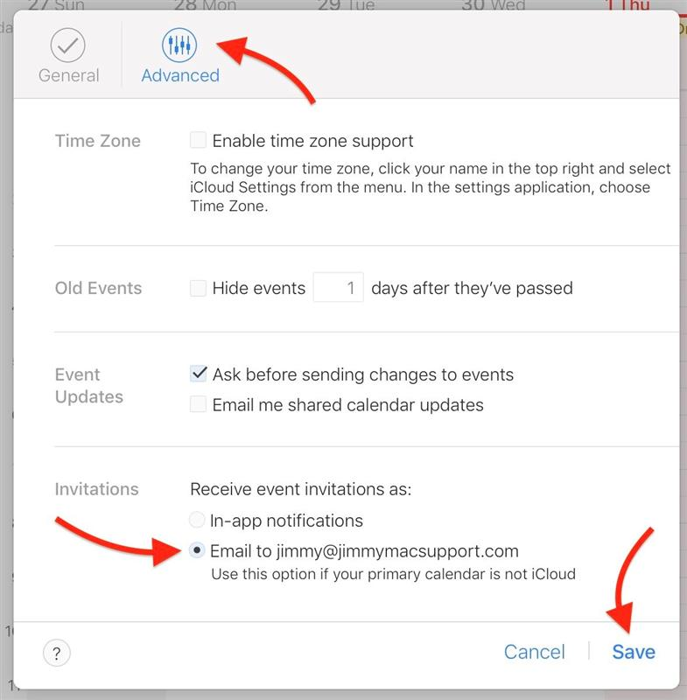  
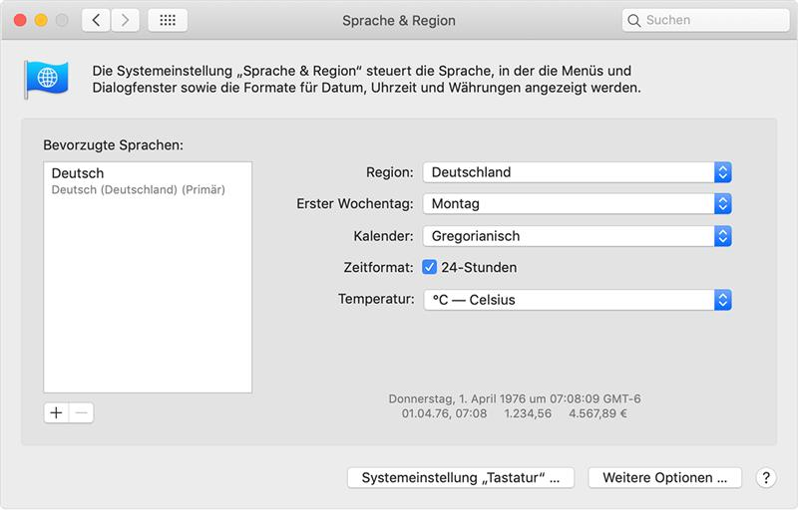

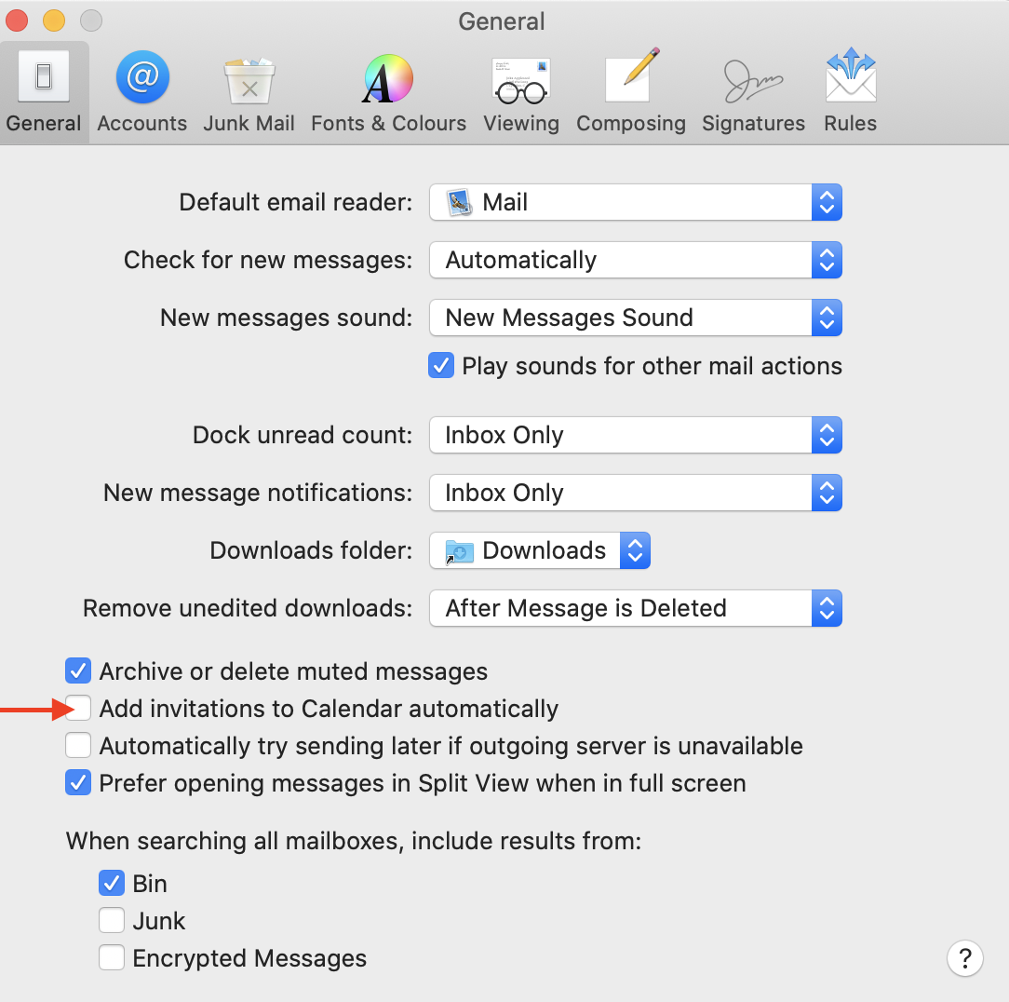

<https://www.slashgear.com/apple-acknowledges-ios-calendar-spam-heres-what-you-can-do-01465873/>

<https://support.google.com/calendar/thread/11020831>